**Dars jadvali**

|  |  |
| --- | --- |
| **Dushanba** | **Seshanba** |
| 1. | 1. |
| 2. | 2. |
| 3. | 3. |
| 4. | 4. |
| 5. | 5. |
| **Chorshanba** | **Payshanba** |
| 1. | 1. |
| 2. | 2. |
| 3. | 3. |
| 4. | 4. |
| 5. | 5. |
| **Juma** | **Shanba** |
| 1. | 1. |
| 2. | 2. |
| 3. | 3. |
| 4. | 4. |
| 5. | 5. |

**O’quvchilar ro’yxati**

1__________________________________________

2__________________________________________

3__________________________________________

4__________________________________________

5__________________________________________

6__________________________________________

7__________________________________________

8__________________________________________

9__________________________________________

10_________________________________________

11_________________________________________

12_________________________________________

13_________________________________________

14_________________________________________

15_________________________________________

16_________________________________________

17_________________________________________

18_________________________________________

19_________________________________________

20_________________________________________

21_________________________________________

22_________________________________________

23_________________________________________

24**_________________________________________**

**Tabriklaymiz**

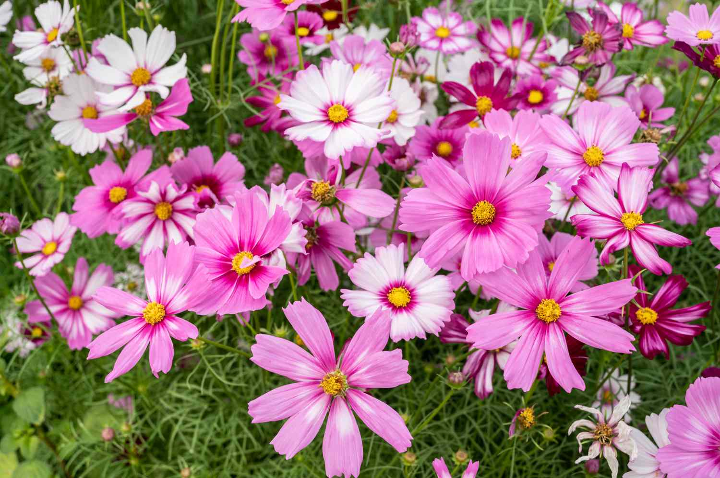

**Sinf faollari**

Sinf sardori:___________________________

Yordamchisi:__________________________

1_____________________

Qator boshliqlari: 2_____________________

3_____________________

Tozalik a’zolari:

__________________________________________________________________________

Mehnat bo’limi:

__________________________________________________________________________

Davomatni aniqlovchi:

_____________________________________

Tashkilotchi:

__________________________________________________________________________